**DATE:** 31/10/2023

**PROJECT ID:** Proj_223334_Team_2

**PROJECT TITLE:** Smart Water Management

**OBJECTIVE’S:**

1. **Real-time Monitoring:** Implement sensors and devices to continuously monitor water quality, quantity, and usage in real-time. This helps in identifying issues promptly and making data-driven decisions.
2. **Water Conservation:** Reduce water wastage and promote efficient water usage by identifying and addressing leaks, unauthorized usage, or overconsumption.
3. **Resource Optimization:** Optimize the allocation of water resources based on demand, weather conditions, and other factors to ensure a sustainable and balanced distribution of water.
4. **Predictive Maintenance:** Implement predictive maintenance for water infrastructure to reduce downtime and operational costs. IOT sensors can help detect equipment failures before they lead to costly repairs.
5. **Water Quality Control:** Monitor water quality parameters such as pH levels, turbidity, and chemical composition to ensure safe and clean water distribution. Take immediate action in case of water contamination or quality issues.
6. **Data Analytics:** Collect and analyze data from IOT sensors to gain insights into usage patterns, trends, and anomalies. This information can be used for informed decision-making and long-term planning.
7. **Remote Control and Automation:** Enable remote control and automation of water distribution systems to respond to changing conditions in real-time, such as adjusting pump speeds or valve positions.
8. **Leak Detection:** Detect and pinpoint leaks in the water supply network quickly, reducing water losses and infrastructure damage.
9. **Compliance and Reporting:** Ensure compliance with regulatory standards and facilitate reporting by automating data collection and documentation.
10. **Sustainability and Environmental Impact:** Promote sustainable water management practices to reduce the environmental impact of water consumption and waste.
11. **Customer Engagement:** Engage customers in water conservation efforts through mobile apps and online platforms, allowing them to monitor their own water usage and receive conservation tips.
12. **Cost Reduction:** Achieve cost savings by optimizing water usage, reducing maintenance expenses, and extending the lifespan of infrastructure.
13. **Disaster Management:** Develop a contingency plan for natural disasters or emergencies, such as floods or droughts, to ensure the resilience of the water supply system.
14. **Integration with Other Systems:** Ensure compatibility and integration with other smart city or infrastructure management systems to optimize overall urban planning and resource allocation.
15. **Scalability:** Design the IOT solution to be scalable, allowing for easy expansion as the water management network grows or as new technology becomes available.

**IOT DEVICE SETUP:**

* Setting up an IOT (Internet of Things) device for smart water management involves several key steps. This technology can help you monitor and control water usage, detect leaks, and optimize water usage.
* Here's a general overview of how to set up such a system:

1. **Define Objectives:** Start by clearly defining your objectives and requirements for smart water management. Determine what aspects of water management you want to address, such as monitoring water usage, detecting leaks, or optimizing irrigation.
2. **Choose IOT Devices:** Select the appropriate IOT devices based on your objectives. Common devices for smart water management include flow sensors, water quality sensors, and valves. Ensure that these devices are compatible with your IOT platform.
3. **IOT Platform Selection:** Choose an IOT platform or a cloud service that will enable you to connect, manage, and analyze data from your devices. Popular options include AWS IOT, Azure IOT, Google Cloud IOT, or dedicated platforms like TTN (The Things Network).
4. **Network Connectivity**: Ensure that your IOT devices have the necessary network connectivity, which may include Wi-Fi, cellular, LORA, or other IOT-specific protocols. Consider factors like range, power consumption, and data transfer rates when selecting connectivity options.
5. **Device Installation:** Install the IOT devices at the appropriate locations. For example, flow sensors can be placed in water supply lines, and water quality sensors can be deployed in water tanks or pipes. Make sure the installation is secure and weatherproof if needed.
6. **Data Collection and Transmission:** Configure the IOT devices to collect and transmit data to your chosen IOT platform. This data might include water usage, water quality, and other relevant information. Ensure data is sent securely to protect against breaches.
7. **Data Processing and Analytics:** Set up data processing and analytics on your IOT platform. This can involve real-time monitoring and historical data analysis to identify patterns and anomalies. Machine learning algorithms can be used to detect leaks or predict water consumption.
8. **User Interface:** Create a user interface for monitoring and controlling your smart water management system. This could be a web application or a mobile app that provides real-time data and control options for users.
9. **Notifications and Alerts:** Implement notification and alert systems to inform users of water usage abnormalities, leaks, or any other issues. Alerts can be sent via email, SMS, or push notifications.
10. **Automation:** Set up automation rules based on the data and analysis. For example, you can automatically shut off a valve when a leak is detected or adjust irrigation schedules based on weather forecasts.
11. **Maintenance:** Regularly maintain and calibrate your IOT devices to ensure accurate data collection. Also, update your IOT platform and user interface as needed to improve functionality and security.
12. **Compliance and Regulations:** Ensure that your smart water management system complies with local regulations and standards, especially if you're using it in a commercial or municipal setting.
13. **Scalability:** Plan for scalability, as your smart water management needs may evolve over time. Be prepared to add more devices or expand the system as necessary.

**PLATFORM DEVELOPMENT:**

* Developing an Internet of Things (IOT) platform for smart water management is a complex and multifaceted task.
* Such a platform should enable the collection, analysis, and control of water-related data from various sources, such as sensors, meters, and other devices.
* Here's a step-by-step guide on how to develop an IOT platform for smart water management:

1. **Define Objectives and Requirements**:
   * Identify the specific goals and objectives of your smart water management platform. Determine what problems you aim to solve, such as water conservation, leak detection, or quality monitoring.
2. **Select the Right Sensors and Hardware**:
   * Choose appropriate sensors and hardware devices that can measure relevant parameters, such as water flow, pressure, temperature, and quality. Ensure they are compatible with your IOT platform.
3. **Data Collection and Connectivity**:
   * Implement a robust data collection infrastructure. IOT sensors should be able to transmit data to the platform over a secure and reliable network, such as Wi-Fi, LORA, or cellular.
4. **Data Processing and Storage**:
   * Set up a database and data processing system to store, manage, and analyze the incoming data. Consider using cloud-based solutions like AWS, Azure, or Google Cloud for scalability.
5. **Security**:
   * Implement robust security measures to protect the data and the platform from unauthorized access or cyber attacks. This includes encryption, authentication, and access control.
6. **User Interface**:
   * Develop a user-friendly web or mobile application that allows users to interact with the platform, view data, set alerts, and control water-related systems remotely.
7. **Data Analytics**:
   * Implement data analytics and machine learning algorithms to gain insights from the collected data. This can help in identifying patterns, anomalies, and optimizing water usage.
8. **Alerts and Notifications**:
   * Create alerting systems that can notify users and administrators in real-time when issues are detected, such as leaks or water quality problems.
9. **Integration**:
   * Ensure your platform can integrate with other existing systems, like water treatment facilities, GIS systems, and city infrastructure.
10. **Compliance and Regulations**:
    * Ensure that your platform complies with local, regional, and national regulations related to water management, data privacy, and environmental standards.
11. **Testing and Validation**:
    * Thoroughly test the platform in various real-world scenarios to ensure it works reliably and meets the defined objectives.
12. **Deployment and Maintenance**:
    * Deploy the IoT platform and provide ongoing maintenance and support to address issues, update firmware, and improve functionality.
13. **Scaling**:
    * Consider scalability options to accommodate future growth and additional sensors or users.
14. **User Training**:
    * Provide training and documentation to users and administrators to effectively use the platform.
15. **Feedback and Continuous Improvement**:
    * Collect feedback from users and monitor the platform's performance to make continuous improvements and updates.
16. **Cost Management**:
    * Keep track of operating costs, and explore energy-efficient solutions to reduce long-term expenses.

**CODE IMPLEMENTATION:**

**import java.util.Scanner;**

**public class SmartWaterManagement {**

**private static int waterLevel = 0;**

**public static void main(String[] args) {**

**Scanner scanner = new Scanner(System.in);**

**while (true) {**

**System.out.println("1. Measure water level");**

**System.out.println("2. Water plant");**

**System.out.println("3. Exit");**

**System.out.print("Enter your choice: ");**

**int choice = scanner.nextInt();**

**switch (choice) {**

**case 1:**

**measureWaterLevel();**

**break;**

**case 2:**

**waterPlant();**

**break;**

**case 3:**

**System.exit(0);**

**break;**

**default:**

**System.out.println("Invalid choice! Please try again.");**

**break;**

**}**

**}**

**}**

**public static void measureWaterLevel() {**

**// This is where you would implement the code to measure the water level using IoT technology**

**// You can use sensors to detect the water level and update the 'waterLevel' variable accordingly**

**// For the sake of simplicity, I'll just ask the user to enter the water level manually**

**Scanner scanner = new Scanner(System.in);**

**System.out.print("Enter the water level: ");**

**waterLevel = scanner.nextInt();**

**System.out.println("Water level measured successfully!");**

**}**

**public static void waterPlant() {**

**if (waterLevel > 0) {**

**System.out.println("Watering the plant...");**

**waterLevel--;**

**System.out.println("Plant watered successfully!");**

**} else {**

**System.out.println("Water level is too low. Please measure water level first.");**

**}**

**}**

**}**

Output:

**1. Measure water level**

**2. Water plant**

**3. Exit**

**DIAGRAM:**

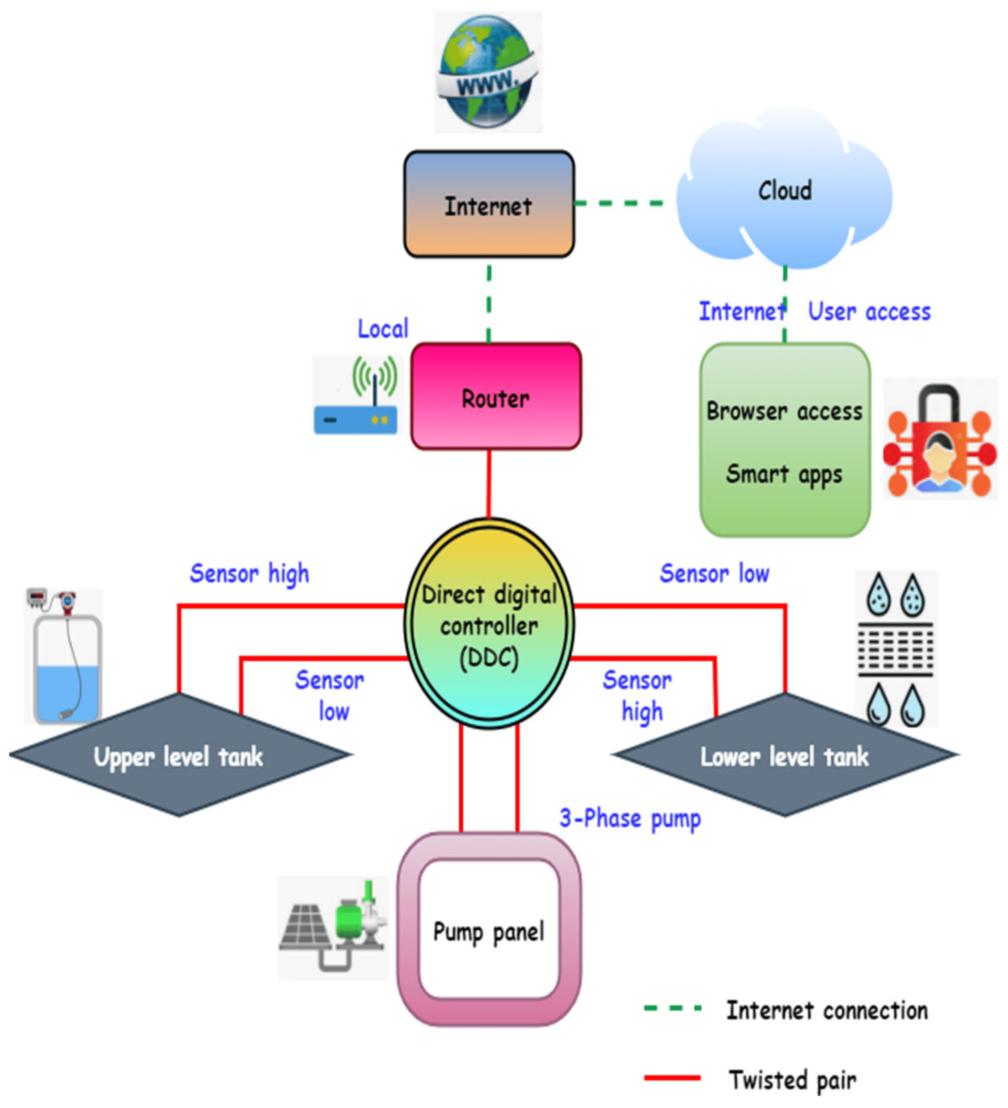

**SCHEMATICS:**

* Creating a smart water management system using IOT (Internet of Things) involves several components, including sensors, microcontrollers, communication modules, and a cloud platform for data analysis.
* Below is a high-level schematic for a smart water management system. Keep in mind that the specific components and designs can vary depending on your requirements and the scale of the project.

**Components:**

1. **Water Sensors:**
   * Flow sensors: These sensors measure the flow rate of water in pipes.
   * Water level sensors: These sensors detect the water level in tanks or reservoirs.
   * Water quality sensors: These sensors measure parameters like pH, turbidity, and conductivity.
2. **Microcontrollers:**
   * Arduino or Raspberry Pi: These can be used as the control units for data collection and communication.
3. **Communication Modules:**
   * Wi-Fi, GSM, or LORA modules: Choose the appropriate communication method based on the location and range of your devices.
4. **Data Processing and Storage:**
   * IOT Gateway: Collects data from sensors and sends it to the cloud.
   * Cloud Platform: Use a cloud service like AWS, Azure, or Google Cloud for data storage and processing.
5. **User Interface:**
   * Web or mobile application: Create a user-friendly interface for users to monitor and control the system.
6. **Control and Actuators:**
   * Valves and pumps: These can be controlled remotely to manage water flow.

**Schematic Overview:**

1. **Sensor Integration:**
   * Connect water sensors to the microcontroller.
   * Depending on the sensor type, use appropriate signal conditioning circuits.
   * Collect data from the sensors.
2. **Data Processing:**
   * The microcontroller processes and preprocesses the sensor data.
   * Data may be transformed and normalized if needed.
3. **Communication:**
   * Use communication modules to transmit data to the IOT gateway.
   * Implement security measures to protect data during transmission.
4. **IOT Gateway:**
   * Collect data from multiple devices.
   * Forward data to the cloud platform.
   * Implement security and authentication.
5. **Cloud Platform:**
   * Store, analyze, and visualize the data.
   * Implement real-time alerts and notifications.
   * Historical data can be used for trend analysis.
6. **User Interface:**
   * Develop a web or mobile app for users to access data.
   * Enable users to control actuators remotely.
   * Provide data visualization, alarms, and reports.
7. **Control and Actuators:**
   * Users can remotely control valves and pumps through the user interface.
   * Implement automation rules for efficient water management.
8. **Maintenance and Monitoring:**
   * Implement monitoring features to track the health of sensors and devices.
   * Set up alerts for maintenance and malfunction.

Top of Form

**SCREENSHOT OF THE IOT DEVICE:**

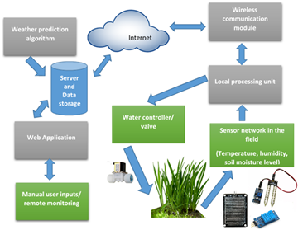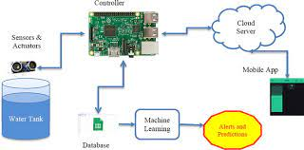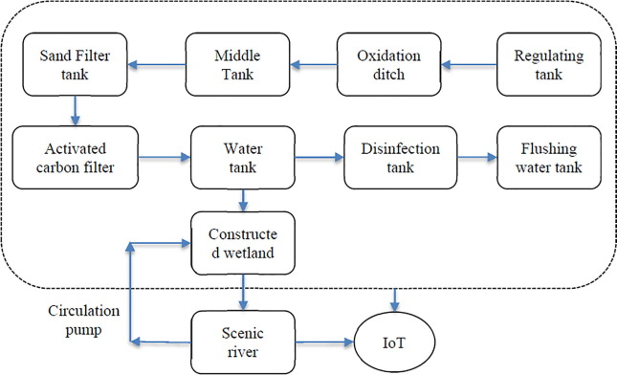Top of Form

Top of Form

Top of Form

Top of Form